Project Design Phase-II
Data Flow Diagram & User Stories
Date | 13 September2026
Team ID | ________________
Project Name | Automated Network Request Management in ServiceNow
Maximum Marks | 4 Marks

Data Flow Diagram
Level-0 data flow for submitting, validating, approving, fulfilling and tracking network service requests.
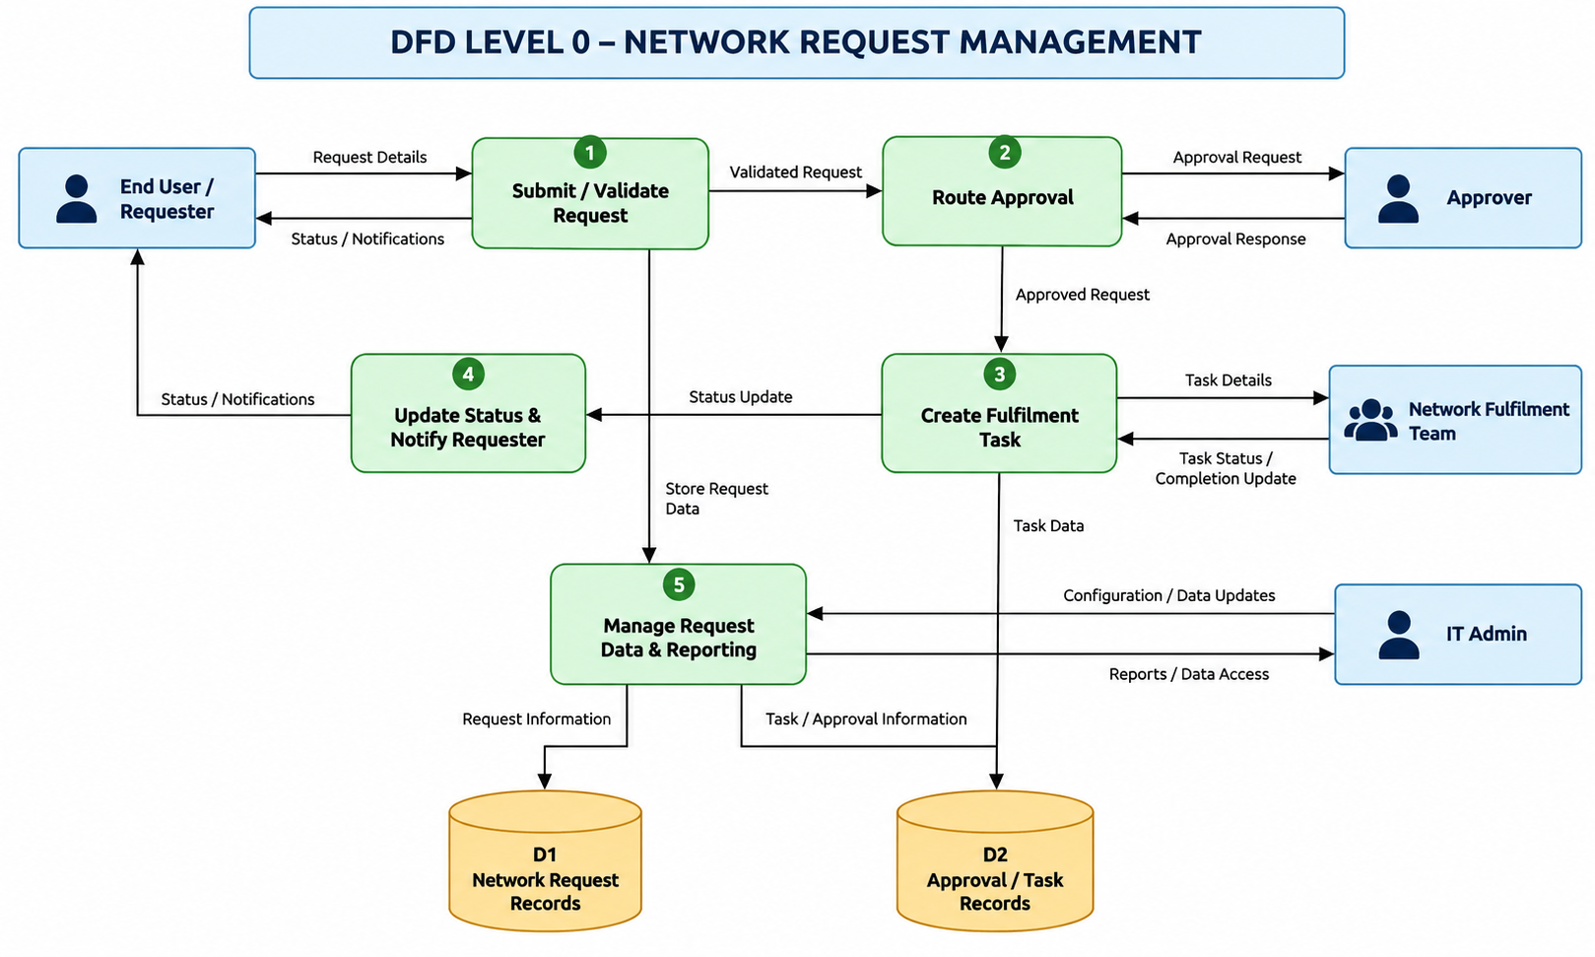

Automation Flow
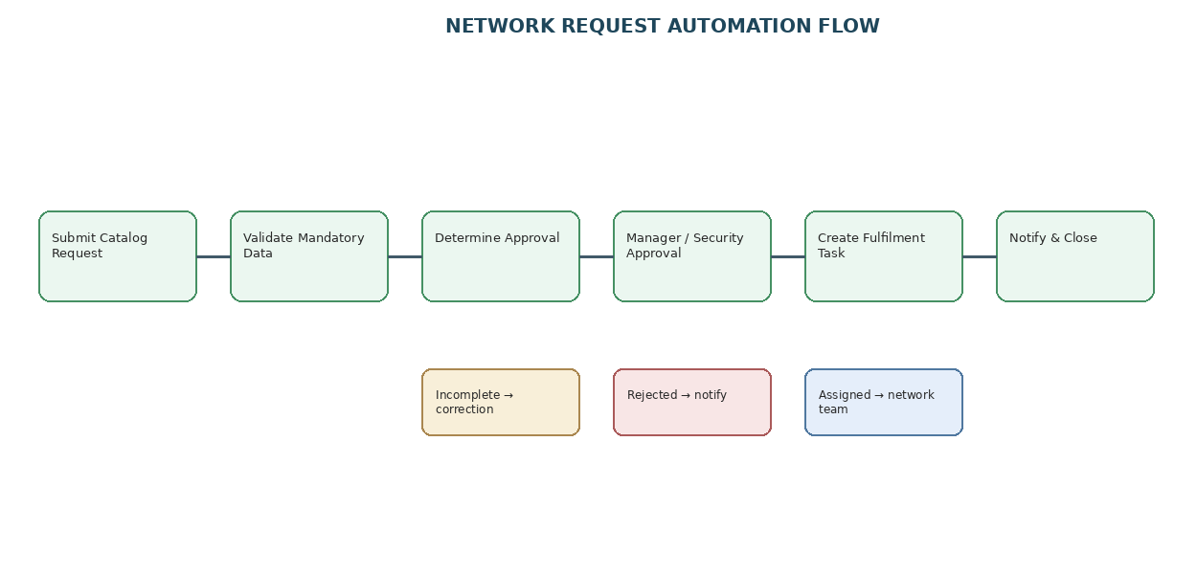
User Stories
User Type | Functional Requirement (Epic) | User Story Number | User Story / Task | Acceptance Criteria | Priority | Release
End User / Requester | Network Request Submission | USN-1 | As a requester, I can submit a network service request through the Service Portal. | Required information is captured and a request is created. | High | Phase-2
End User / Requester | Request Tracking | USN-2 | As a requester, I can view the status of my network request. | Current request/fulfilment status is visible. | High | Phase-2
Approver | Approval Management | USN-3 | As an approver, I can approve or reject a network request. | Decision is recorded and workflow follows the decision. | High | Phase-2
Network Fulfilment Team | Task Fulfilment | USN-4 | As a network team member, I receive an automatically generated fulfilment task. | Task contains approved request details and correct assignment. | High | Phase-2
IT Admin | Configuration | USN-5 | As an IT administrator, I can maintain request fields, routing and workflow configuration. | Configuration can be maintained for the request process. | Medium | Phase-2
End User / Requester | Notifications | USN-6 | As a requester, I receive lifecycle notifications. | Submission, approval/rejection and completion events generate notifications. | Medium | Phase-2

